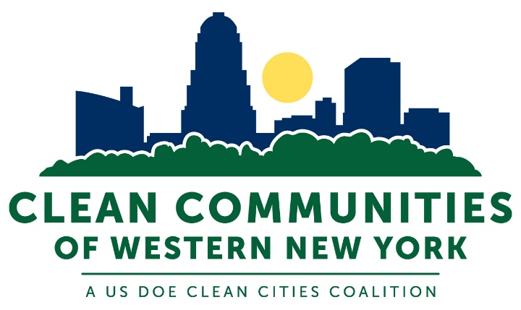

Clean Communities of Western New York Clean Cities Coalition
Partnership Agreement

The organization below wishes to express its commitment to, and support for, the Clean Communities of Western New York, Clean Cities Coalition efforts to support the nation’s energy and economic security, by building partnerships to improve transportation energy efficiency and advance affordable, domestic transportation fuels and technologies.

_______________________________________________________________
Organization Name

________________________________________________________________
Organization Address

_________________________________________________________________
City, State, ZIP

_______________________________ _________________________________
Phone Web address

_______________________________
Email

__________________________________ ________________________
Signature of Organization Representative Date

__________________________________ _________________________
Name (PRINTED) Title

Stakeholder/Member Responsibilities

Please check any of the commitments you wish to make on behalf of your organization/business to support the Clean Communities of Western New York Clean Cities Coalition.

_____ My organization/business commits to incorporating the use of alternative fuels in our fleet to the extent feasible.

_____My organization/business commits to supporting the development of refueling, service and/or maintenance facilities for alternative fuel vehicles in the Clean Communities of Western New York Clean Cities Coalition’s region.

_____ My organization/business will assist the Clean Communities of Western New York Clean Cities Coalition in achieving its goals of promoting alternative fuels and reducing emissions by supporting legislation encouraging the use of alternative fuels, advanced technology vehicles and other fuel efficiency strategies.

_____ My organization/business will assist the Clean Communities of Western New York Clean Cities Coalition with increasing public awareness of the energy security and air quality benefits of alternative fuels, advanced technology vehicles and other fuel efficiency strategies.

_____ My organization/business will assist the Clean Communities of Western New York Clean Cities Coalition by providing in-kind services, to the extent feasible.

_____ My organization/business commits to implementing idle-reduction measures and technologies to the extent feasible, to promote efficient fuel use and decrease emissions.

Information on the U.S. Department of Energy’s Clean Cities Program can be found at: www.cleancities.energy.gov

The Clean Communities of Western New York Clean Cities Program Plan can be found at:
www.ccofwny.org

